 | NCDOT Guidance for Assessing Indirect  and Cumulative Effects

INTRODUCTION

Purpose and Background
The purpose of the ICE Guidance Document is to define the procedure for conducting Indirect and Cumulative Effects (ICE) analysis for a proposed NCDOT roadway project. It assists with the completion of the ICE Report Template, available as a separate document. The resultant ICE Report, which is to be completed by Community Studies (CS) Staff and/or Project Consultants, is intended to review and document the scope, purpose and need of the project, other projects proposed in the area, population and employment trends and forecasts, details on the study area’s current and future development market, available land, and water and sewer service availability. It calls for a site visit, interviews with local staff and stakeholders, and a review of the local and state development regulations. The ICE procedure determines whether indirect and cumulative effects are “possible” or “likely” as a result of project construction and any subsequent public and private development actions.
This procedure also determines whether more detailed analysis in the form of a Land Use Scenario Assessment (LUSA) is warranted based on the results of the Indirect Effects Matrix and general conclusions. The LUSA Guidance Document, available as a separate document, provides further detail on the LUSA procedure. The ICE Report and LUSA Report provide the Project Manager, Project Delivery Team, and NCDOT Project Development Unit with the information needed to avoid and minimize potential impacts and/or adequately prepare for the permitting process and any required mitigation and permitting issues that may arise in the future. If the LUSA findings indicate high levels of concern for potential for indirect land use impacts, NCDOT Natural Environment Section (NES) can initiate an Indirect and Cumulative Impacts (ICI) Water Quality assessment.
The ICE Report will have various audiences—internal NCDOT decision-makers and regulatory and environmental resource agencies such as the US Army Corps of Engineers and the NC Division of Water Resources, as well as additional agencies where appropriate (for Merger projects, all Merger Team members will be included). The distribution of the document should conform to the “Distribution lists for Community Studies reports” memo sent from CS to Project Managers in January 2014. The memo identifies individuals to whom final versions of CS reports should be distributed.

Initiation of Procedures
The ICE procedures are initiated through the Environmental Tracking and Coordination System (ETRACS). Initiation of procedures is based on several factors: CS timeline memo, project management decisions, project type, and funding. CS decides whether a LUSA is warranted based on the results of the ICE and consultation with the Project Manager (see Part E of this ICE Guidance Document).

FORMAT AND USE OF GUIDELINES
This ICE Guidance Document is intended to assist the planner with completing an ICE analysis for a proposed NCDOT project. It provides step-by-step directions for: conducting an interview, completing the Indirect Effects Matrix, and preparing the ICE Report Template. These documents are separate from the guidance, and available from the CS Group. This guidance is organized into four parts:
- Part A. Project Initiation and Set-Up
- Part B. Conduct Base Screening
- Part C. Verify Base Screening
- Part D. Conduct Analytical Screening
- Part E. Analyze and Evaluate Data

Use of Guidelines
The recommended approach for users of this guidance is to read through the document in its entirety to familiarize themselves with the ICE process. The procedural guidance outlined below includes steps with corresponding icons depicting the action(s) performed. These include:
 | Step involves project initiation and coordination with the CS Group
 | Step involves a developing Project Mapping. |  | Step involves conducting a Field Visit of the FLUSA, which may be done concurrently with interviews.
 | Step involves submitting the proposed FLUSA to the CS Group for approval before proceeding. |  | Step involves rating categories in the Indirect Effects Matrix.
 | Step involves conducting an interview with local planners and stakeholders using the ICE Comprehensive Interview Form. |  | Step involves completing sections of the ICE Report Template.

Scheduling and Time Constraints
The ICE Report informs development of both 1) purpose and need and 2) detailed study alternatives (Concurrence Points (CP) 1 and 2 within the Merger Process) and is initiated in combination with the Community Characteristics Report (CCR), if warranted, as shown in the timeline below. The LUSA occurs after the ICE Report and selection of the preferred alternative (CP 2 within the Merger Process), if warranted.
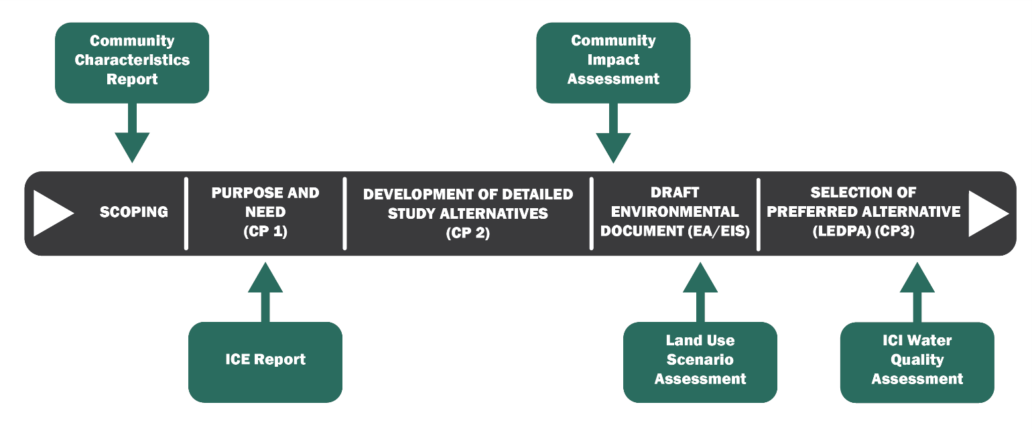

Responsibility
The CS Group is responsible for ICE analysis. Community Planners in the CS Group and/or Project Consultants are typically assigned projects as information is requested by the project team.

Policy, Regulatory, and Legal Requirements
Additional information about the National Environmental Policy Act (NEPA) can be found at the following website address:

Federal Highway Administration (FHWA)
https://www.environment.fhwa.dot.gov/projdev/pd2implement.asp

Additional information about the State Environmental Policy Act (SEPA) can be found at the following website address: http://www.ncleg.net/EnactedLegislation/Statutes/HTML/ByChapter/Chapter_113A.html

PART  A | Project Initiation and Set-Up
1 | Coordinate with NCDOT CS Group
A |  | Determine which ICE Report Template to use by coordinating with the CS Group.  The ICE Report Template is generally used for less complex projects while the ICE Narrative Report Template is often used for more complex projects.
B |  | Review project information, define the regional context of the project, and review online resources for trends, notable features and initiatives in the area.
C |  | Obtain the accompanying ICE documents from Connect NCDOT or from CS Staff:  - ICE Report Template or ICE Narrative Report Template  - ICE Comprehensive Interview Form  - Indirect Effects Matrix  This ICE guidance is intended to be flexible to meet the individual needs of each project. Consult with the CS Group if the project warrants the steps to be completed in an order different from the one presented in this document.
2 | Determine the Future Land Use Study Area
A |  |  | Collect transportation and land use plans pertinent to the project in order to help define the Future Land Use Study Area (FLUSA). The following information for each plan should be summarized in the table. An example is provided below.  In addition, collect GIS data needed to determine the FLUSA and produce the GIS maps listed in Appendix B: Mapping Guidance.
  Plan Title | Horizon Year | Planning Boundary
  2045 Metropolitan Transportation Plan | 2045 | MPO Boundary
B |  |  | Determine and develop mapping of the area to be assessed for indirect and cumulative effects. The boundary should include all parcels that could be indirectly affected by the project and combined projects. The boundaries of the FLUSA should run along property lines, watershed boundaries, waterways or ridgelines where possible. They should also be consistent whenever possible with adopted land use and transportation plans. Roadways, right-of-way lines and county or state boundaries should not be used arbitrarily. Because the FLUSA is used primarily as a boundary for gathering base data, it is generally better to err on the side of making the FLUSA too large rather than too small. On projects that will likely have multiple geographically separated alternatives, the FLUSA should be defined to encompass these alternatives, and may include Hydrologic Unit Codes (HUC) boundaries, especially if high levels of concern for indirect effects are anticipated, and where an NES ICI Water Quality assessment may potentially be indicated. Clearly document the reasons the boundaries for the FLUSA were selected. Refer to Appendix B: Mapping Guidance.
C |  |  | The proposed draft FLUSA should be mapped and forwarded to the CS Group for review and approval before the analysis is conducted.
3 | Identify the Preliminary ICE Study Time Horizon
A |  |  | Based on the planning horizons of the land use and transportation plans identified in Step 2A, identify a preliminary ICE Study Time Horizon. The ICE Study Time Horizon should correspond as closely as possible to the project design year. This preliminary time horizon will be confirmed with the CS Group and Project Stakeholders.
4 |  | Identify Project Stakeholders
A |  |  |  | In consultation with CS Staff, identify the relevant project stakeholders from the local NCDOT Division, metropolitan/rural planning organizations (MPO/RPO), and county and municipal planning departments. Representatives from education (K-12, community colleges and universities), businesses, chambers of commerce, real estate, workforce development, and public and/or private utility providers may also be identified as project stakeholders.  Stakeholders may be consulted as necessary during the course of the ICE Report for their input and local knowledge. Below is a sample table that may be used to document the stakeholder and contact information relevant to the project. This table is also included in the ICE Report Template.
Affiliation | Name | Email | Phone | Response (Y/N)
NCDOT Division
MPO/RPO Planner
County Planner
Municipal Planner
Other

PART  B | Conduct Base Screening
1 | Project Overview
A |  | Prepare a summary of the project details.  The Project Overview should include the purpose and need of the project, the length of the project, the typical roadway section, the proposed design speed, whether the project will be on a new location or existing alignment, the current and projected annual average daily traffic count (AADT), and major connecting routes along the project. The project’s location relative to nearby municipalities and counties should be noted in the narrative description.  The ICE Study Time Horizon should be documented in this section as well. Discuss how this time horizon relates to the time horizons of the identified land use and transportation plans pertinent to the FLUSA.  The summary should note whether the project is proposed to affect economic development in the FLUSA or to serve a specific development. This should reflect local goals for economic development, not just the purpose and need for the project. The summary should also note the type of environmental document being produced and note the level of study typically associated with the document type.
2 | Determine the Other Transportation, Infrastructure, and Active Development Projects in the FLUSA
A |  | List the other notable public and private projects underway or foreseeable in the FLUSA.  Determine the other transportation, infrastructure, and active development projects in the FLUSA by public and private entities by consulting local zoning and permitting staff and economic development staff. Distinguish between projects that are permitted and underway versus those that are planned and/or pending approval.  NCDOT projects are limited to the notable projects listed on the State Transportation Improvement Plan (STIP) or on a fiscally constrained long-range Metropolitan Transportation Plan (MTP). Notable projects are defined as those that will potentially affect mobility and accessibility within the FLUSA.  Local infrastructure or road projects are limited to projects that are currently under construction, are funded, or are being planned with a clear funding stream. Summarize the likely modifications proposed by each project.  North Carolina STIP Access Information  North Carolina STIP information can be found at the following website address:  https://connect.ncdot.gov/projects/planning/pages/state-transportation-improvement-program.aspx  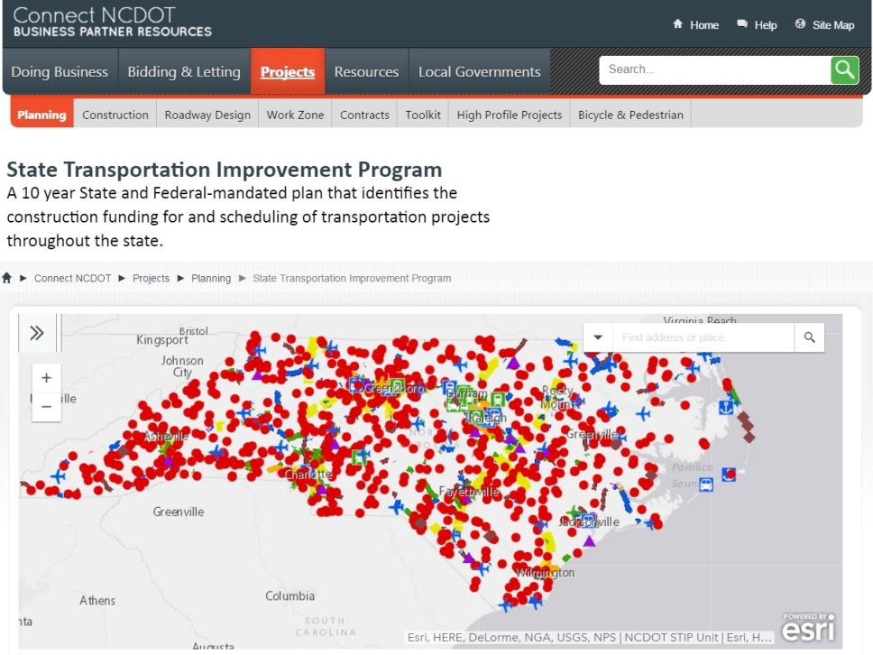
B |  | Map the other notable public and private projects underway or foreseeable in the FLUSA.  Produce a map showing the location of other notable public and private projects underway or foreseeable in the FLUSA. Refer to Appendix B: Mapping Guidance for map requirements.

3 | Gather and Summarize the Population Trends and Projections in the FLUSA
A |  | Document and provide support for the annualized rate of population growth or decline expected in the FLUSA to the time horizon for the study.  Review and document the county population trends and county population projections based on the North Carolina State Demographer’s official estimates. Specifically document population trends or projections in the FLUSA that diverge notably from the county trends. Weight the population trends and projections in a multi-county area toward the characteristics of the FLUSA. Clearly document the method used.  Population Trends and Projections Access Information  The population trends and projections can be found at the following website address and location: http://www.osbm.nc.gov/facts-figures/demographics County Populations Annual County Population  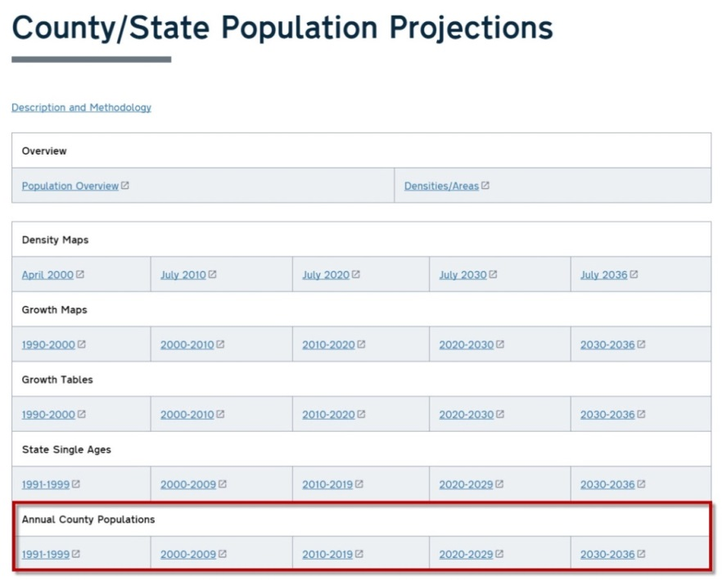  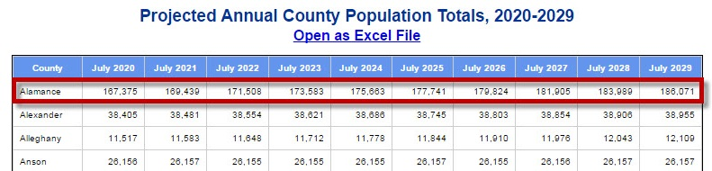
B |  | Calculate Annualized Growth Rate  The annualized population growth rate may be calculated using the Annualized Growth Calculator from Community Studies, which is an Excel-based tool. It is available on Connect NCDOT at the following website address:  https://connect.ncdot.gov/resources/Environmental/PDEA%20Consultants/Annualized%20Growth%20Calculator.xls  Alternatively, the annualized population growth rate may be calculated using the equation provided below:  $${\left(\frac{{Population}_{Time Horizon}}{{Population}_{Current Year}}\right)}^{\left(\frac{1}{Years}\right)-1 }$$  For example, the annualized population growth rate for Alamance County between July 2020 and July 2030 would be:  $${\left(\frac{186,071}{167,375}\right)}^{\left(\frac{1}{10}\right)-1}=1.1\%$$
C |  | Complete the Matrix category “Forecasted Population Growth” by using the rankings below:  .
  Ranking | Forecasted Population Growth
  High | Greater than 3% annualized population growth
  Medium-High | Annualized Population Growth >2% - 3%
  Medium | Annualized Population Growth >1% - 2%
  Medium-Low | Annualized Population Growth >0% - 1%
  Low | Annualized Population Growth 0% or less (Decline)

4 | Gather and Summarize the Employment Trends and Projections in the FLUSA
A |  | Document and provide support for the rate of annualized job growth expected in the FLUSA to the time horizon for the study.  Review and document the employment projections for the FLUSA by using projections from Woods & Poole Economics, Inc. Note that projects involving Environmental Impact Statements (EIS) and/or any multi-county projects with new location corridors or additional capacity will use NC Department of Commerce-Labor and Economic Analysis data as it provides a regional context.  Woods & Poole Economics, Inc. Access Information  Woods & Poole Economics, Inc. detailed demographic and economic data for the county in which the FLUSA is located can be purchased at the following website address: www.woodsandpoole.com.  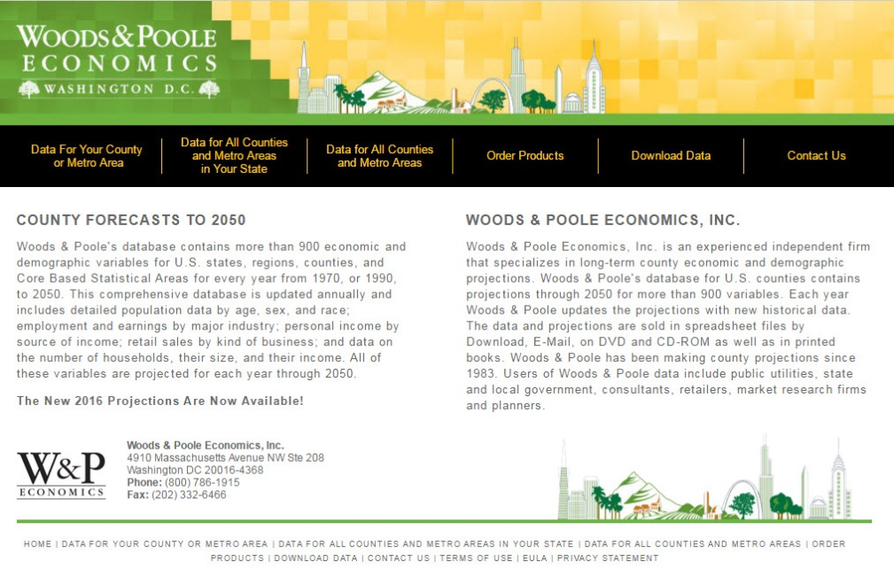  Woods and Poole Economics, Inc.  Document the data source used for employment projections. Based on local knowledge, document employment trends or projections in the FLUSA that diverge notably from the prosperity zone or county trends. In lieu of FLUSA-specific employment trends or projections, note the existing employers and anticipated employers within the FLUSA. Weight the employment trends and projections in a multi-county area toward the characteristics of the FLUSA. Clearly document the method used.
A |  | For projects involving Environmental Impact Statements (EIS) and/or any multi-county projects with new location corridors or additional capacity, use the NC Department of Commerce-Labor and Economic Analysis data.  NC Department of Commerce-Labor and Economic Analysis Data  The Department of Commerce provides statewide employment projections and projections for each of the eight prosperity zones as shown in the map below:  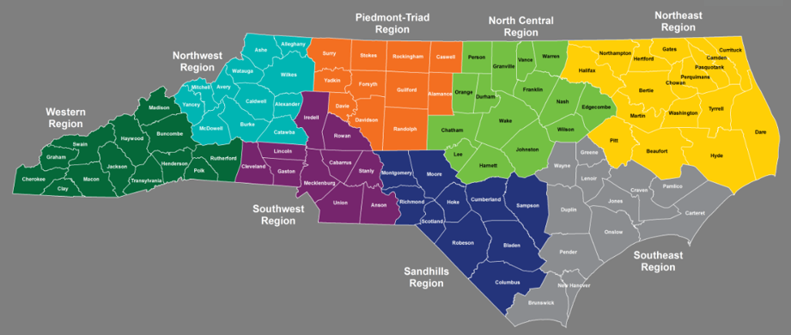  North Carolina Prosperity Zones, North Carolina Department of Commerce.  Review and document the annualized employment projection for the prosperity zone in which the project is located. An example of the employment projections available from the Department of Commerce is shown below. Parameters that should be selected in the projection tool are outlined in red. The annualized employment projection is highlighted in yellow and outlined in red.  The Department of Commerce data is free and can be found at the following website address and location: http://nccareers.org/ Employment Projections (http://nccareers.org/employmentprojections/industry_employment_projections.html)

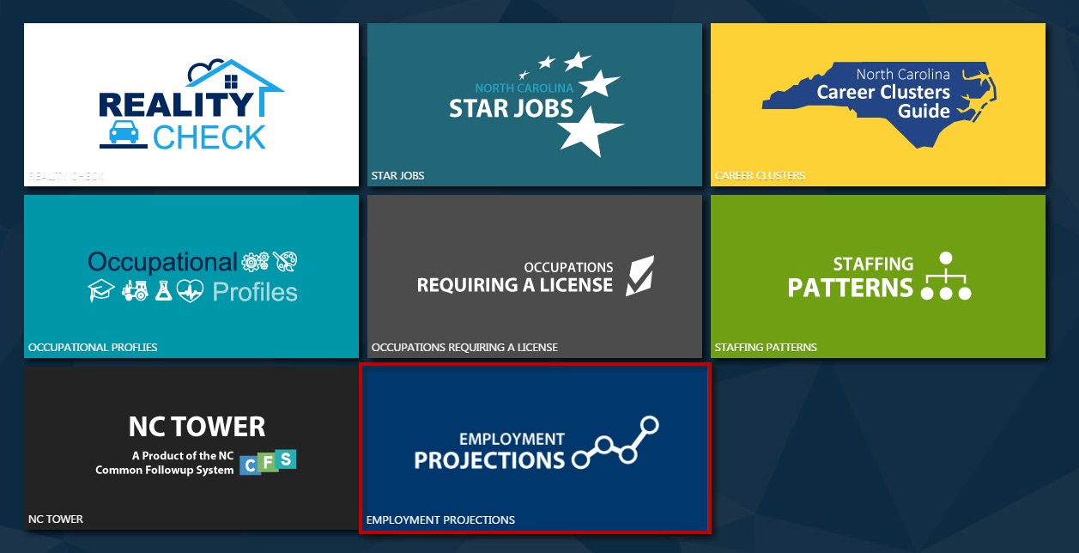
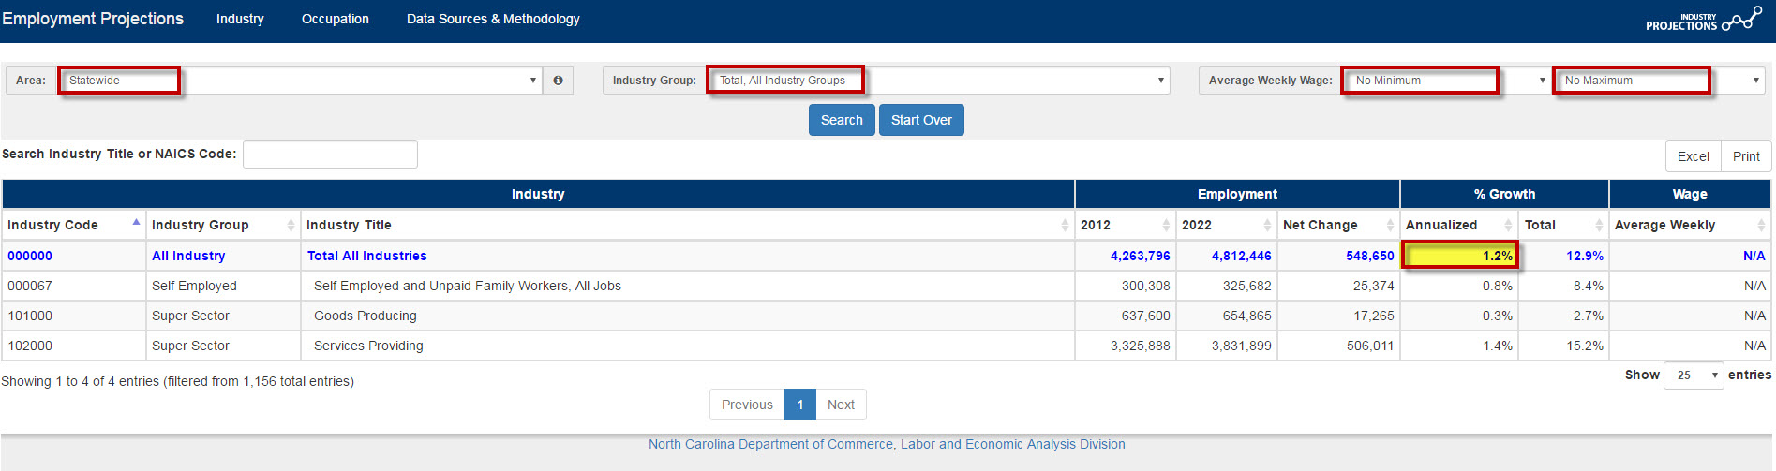

B |  | Complete the Matrix category “Forecasted Employment Growth” by using the rankings below:  .
  Ranking | Forecasted Employment Growth
  High | Greater than 3% annualized employment growth
  Medium-High | Annualized Employment Growth >2% - 3%
  Medium | Annualized Employment Growth >1% - 2%
  Medium-Low | Annualized Employment Growth >0% - 1%
  Low | Annualized Employment Growth 0% or less (Decline)

5 | Document Notable Human and Natural Environmental Features in the FLUSA
A |  | List the notable human and natural environmental features in the FLUSA.  Notable features are those resources that are identified by local officials, organizations, or agencies as important, special, or unique. Examples of notable human features would include, but are not limited to: community centers, preservation designations, and cohesive communities. Examples of notable natural environmental features would include, but are not limited to:, habitat areas, Natural Heritage Program Natural Areas, major waterways, wetlands, water supply watershed areas, waters under jurisdiction of a NC Basin-wide Management Plan, 303(d) listed streams, trout streams, Outstanding Resource Waters, NC Natural & Scenic Rivers, and US Wild & Scenic Rivers.  The report should clearly note the geographic location of the notable features within the FLUSA. Coordinate the notable feature identification process with other reports underway or completed, such as the Community Characteristics Report (CCR) and Community Understanding Report (CUR) to be completed as part of long-range planning/CTP development.  Water classifications are available from the North Carolina Department of Environmental Quality Water Resources Division:  https://deq.nc.gov/about/divisions/water-resources/planning/classification-standards/
B |  | Map the notable human and natural environmental features.  Produce one map showing the locations of the notable human environmental features and a second map showing the locations of the notable natural environmental features. Refer to Appendix B: Mapping Guidance for map requirements.
C |  | Complete the Matrix category “Notable Natural Environmental Features.”  The notable natural environmental features should be ranked based on sensitivity and abundance in the Matrix category “Notable Natural Environmental Features.” Only natural environmental features should be ranked in the Matrix. Human environmental features should be documented in narrative, but not ranked. Sensitivity of a natural environmental feature can be determined by consulting local, state, and federal regulations, programs, and agencies overseeing these notable resources such as the NC Division of Water Resources as well as discussion with local representatives knowledgeable about area resources. Several examples of more sensitive natural environmental features would be those protected by conservation easements, waters classified as High Quality Waters (HQW), and species listed as threatened or endangered. Less sensitive natural environmental features would be those that do not have specific protection, do not appear on the lists of threatened or endangered species, are not classified as sensitive waters, or may be deemed to be of little environmental importance by local representatives.  The category is also ranked based on abundance within the FLUSA. As this category is qualitative, the staff’s best professional judgment should be used to take into account both the sensitivity and abundance of the resource. For example, if there are a few notable natural environmental features, this category may be given a medium ranking, since abundance is low but sensitivity is high. Note that a high ranking would suggest several natural environmental features that are more sensitive and a low ranking would indicate that there are very few natural environmental features that are less sensitive. Examples are provided below:  The surface water classifications referenced in the examples above are from the NC Division of Water Resources: https://deq.nc.gov/about/divisions/water-resources/planning/classification-standards/classifications.
  Ranking | Notable Natural Environmental Features Examples
  High | Threatened or endangered species habitat; High Quality Waters (HQW); Unique Wetland (UWL); and parks
  Medium-High | Large-scale intact habitat with wildlife not listed as threatened or endangered; 303(d) listed streams; and wetlands (classified as WL or SWL)
  Medium | Moderate-scale intact habitat with wildlife not listed as threatened or endangered; 303(d) listed streams; wetlands (classified as WL or SWL)
  Medium-Low | Small-scale intact habitat with wildlife not listed as threatened or endangered; streams (Class B)
  Low | Fragmented habitat with little or no observed wildlife in a developed area; streams (Class C)

PART  C | Verify Base Screening
1 | Conduct Interviews with Local Planners and Project Stakeholders
A |  | Verify and supplement the base screening information completed in Part B by conducting an interview(s) with local planner(s) from the municipality, county, and/or MPO/RPO where the project is located. The interviews are intended to augment the ICE Report with knowledge and insights from local planners.  Refer to the ICE Comprehensive Interview Form, which should be used during an in-person interview or emailed to the planner(s) for completion.
B |  | Interviews with other project stakeholders may be conducted. All interviews should be documented and included in the ICE Report (refer to ICE Template).

2 | Conduct Field Visit and Document Findings
A |  | Notify CS Staff and the local NCDOT Division Project Development Unit contact via email prior to conducting the field visit of the FLUSA.  Document the findings in the corresponding sections of the ICE Report. Photographs should be taken of existing land uses, notable human and natural environmental features, and any indications of development within the FLUSA. Include these photographs in the ICE Report (refer to ICE Template).  The field visit may be done concurrently with the interviews.

PART  D | Conduct Analytical Screening
1 | Evaluate the Scope of the Project
A |  | Document the scope of the project in terms of Transportation Impact Causing Activities (TICAs).  This should include activities such as estimated travel time savings, change in property access, change in and creation of new network connections, and the likelihood that the project and combined projects in the FLUSA will create an activity center.
B |  | Complete the Matrix category “Scope of Project.”  A high ranking denotes projects that would create new transportation or land use nodes, increase accessibility, increase property access, and alter existing travel patterns. A low ranking would denote projects that do not create new transportation or land use nodes and have limited impact on accessibility, property exposure and access, and traffic patterns. Refer to Appendix D: Scope of Project Definitions for further guidance. Examples are provided below:  .
  Ranking | Scope of Project Examples
  High | Linear project on new location that would significantly increase accessibility and create land use nodes, encouraging development
  Medium-High | Linear project on new location that would moderately increase accessibility and may or may not encourage new development
  Medium | Linear improvements to existing such as widening that would increase capacity thereby improving accessibility, may or may not encourage new development
  Medium-Low | Linear or spot improvements to existing (no widening) such as lane or intersection reconfigurations that would alter existing travel patterns and increase property access
  Low | Linear or spot improvements to existing (no widening) such as lane reconfigurations, and safety improvements that would have no to limited impact on accessibility, property access, and traffic patterns

2 | Assess the Travel Time Savings
A |  | Document estimated travel time savings associated with the project.  Document the estimated travel time savings that would result due to this project and discuss how a change in travel time may affect commuting patterns and development. Travel time savings should be calculated by comparing the Present No-Build and Present Build alternatives. Typically, greater travel time savings are associated with more changes in the frequency or intensity of development patterns. Traffic forecasts conducted for the project or trip estimating software can produce the savings in travel time needed for this assessment; however, this information may not be available during early planning thereby requiring alternative methods to estimate travel time.  Travel time savings is often a principal benefit of a transportation project. Examples of projects include construction of additional roadway capacity and other improvements that allow for faster travel along a corridor.  Estimate travel time savings using one of the methods below:  Quantitative Method: The quantitative method relies on traffic forecasts conducted for the project or trip estimating software. It should be based on the comparison of the Present No-Build and Present Build alternatives. NCDOT Transportation Planning Branch may be able to assist with this assessment.  Qualitative Method: The qualitative method uses professional judgment to determine Travel Time Savings. Qualitatively estimate the travel time before and after project implementation using estimates of local knowledge of delays and savings resulting from the proposed improvement. The travel time calculator located at the following website address may be helpful in determining a qualitative estimate:  http://www.csgnetwork.com/csgtsd.html
B |  | Complete the Matrix category “Travel Time Savings” by using the rankings below:  .
  Ranking | Travel Time Savings
  High | 10 or more minutes
  Medium-High | 6 - 9 minutes
  Medium | 3 - 6 minutes
  Medium-Low | 0 - 3 minutes
  Low | 0 minutes

3 | Detail the Location and Plan for Water and Sewer Lines in the FLUSA
A |  | Document the existing and planned capacity and current usage at the water and wastewater treatment plants in the FLUSA.  Note the location of existing infrastructure within existing water and sewer service areas as well as planned future extensions of utility service. Document the plans, policies, and budgets, if available, to extend water and sewer lines. For private water and sewer utilities, contact the utility owner to determine future plans for extensions. Report on the likelihood that the FLUSA will have public or private water and/or sewer service by the horizon year. The water and sewer discovery process should be coordinated with other reports underway or completed. In addition to water and sewer lines, document the current and projected capacities of water and wastewater treatment plants that serve the FLUSA, if applicable.  Local Water Supply Access Information  Local water supply plans for North Carolina can be found at the following website address and location: www.ncwater.org Public Water Supply (at bottom of page) Local Water Supply Plans (right sidebar) Quick Search (right sidebar).

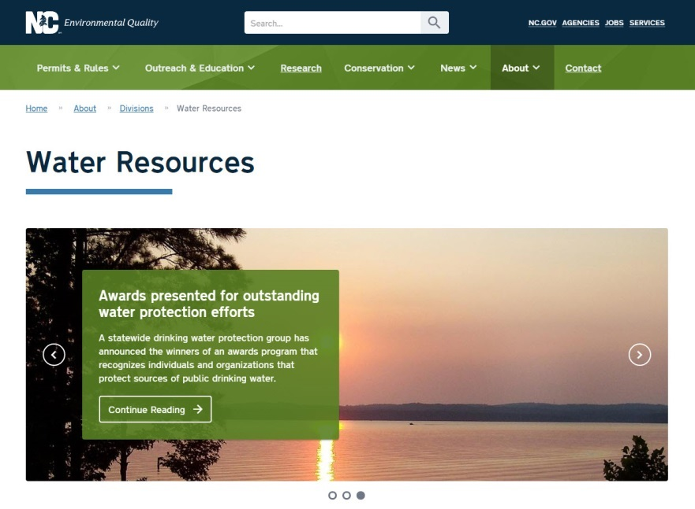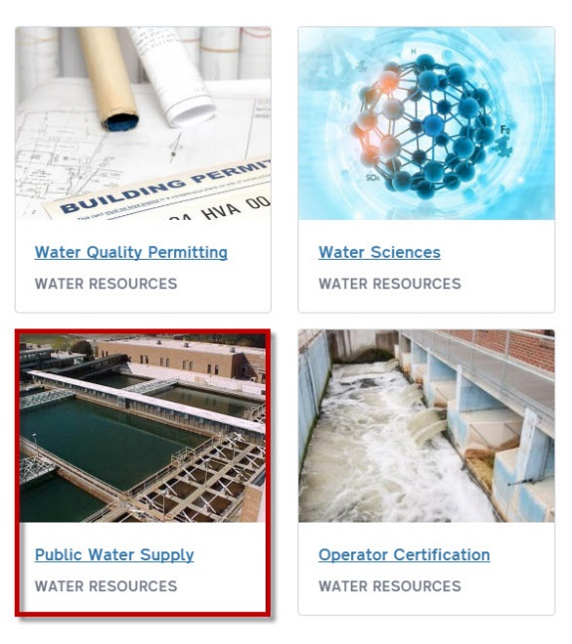
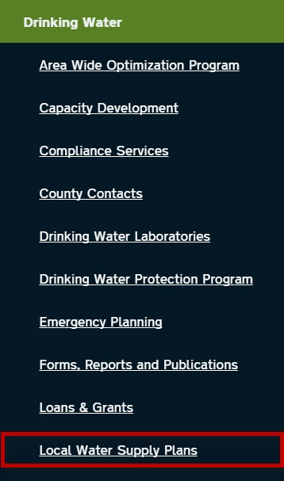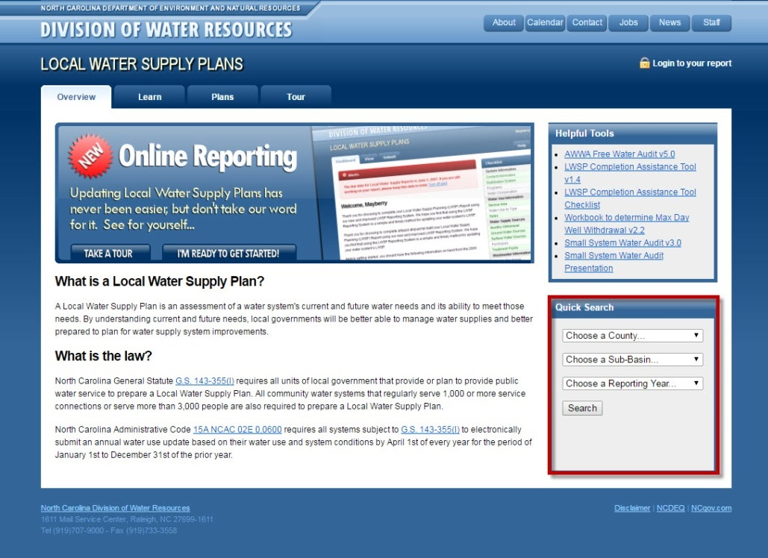

B |  | Map the water and sewer availability within the FLUSA.  Produce a map showing the locations of water and wastewater treatment plants, existing and future water distribution and sewer service areas. Refer to Appendix B: Mapping Guidance for map requirements. GIS layers of this data may be available from the local planning and/or public works departments and NC One Map. The local planning or public works department may have a service map available such as the example shown below from the Orange Water and Sewer Authority (OWASA). In the absence of GIS layers, create a map showing the generalized locations.  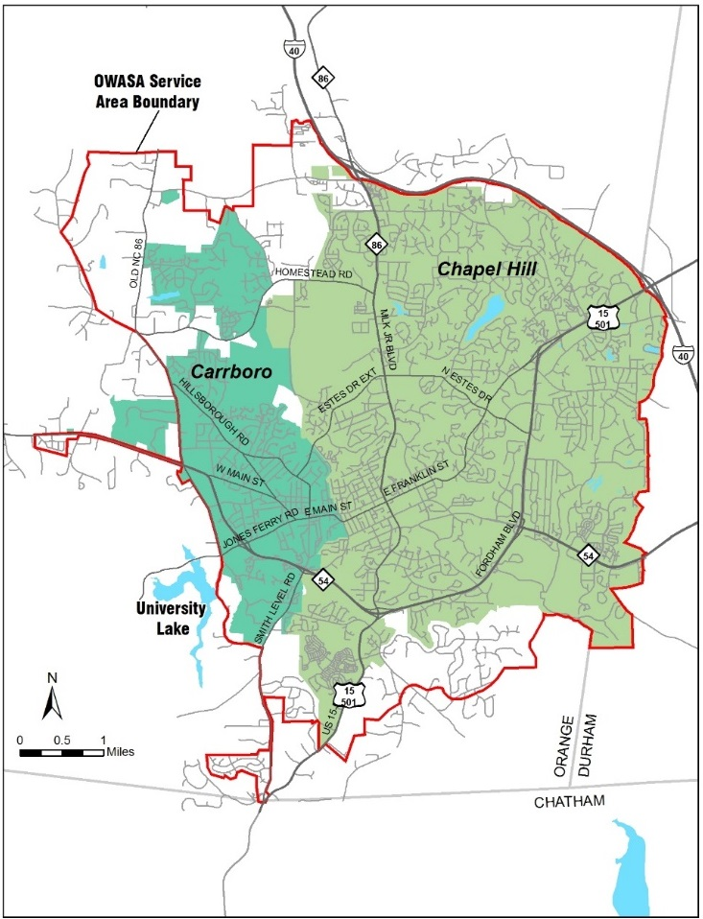  Orange Water and Sewer Authority, 2016.
C |  | Complete the Matrix category “Water and Sewer Availability” by using the rankings below:  If water and sewer availabilities are different, then use the average. This assessment should be based on water and sewer availability within the ICE Study Time Horizon.
  Ranking | Water and Sewer Availability
  High | 80 - 100% of the FLUSA served
  Medium-High | 60 - 80% of the FLUSA served
  Medium | 40 - 60% of the FLUSA served
  Medium-Low | 20 - 40% of the FLUSA served
  Low | 0 - 20% of the FLUSA served
4 | Estimate Available Land in the FLUSA
A |  | Identify available land either qualitatively, using best professional judgment, or preferably quantitatively, using GIS data.  Available Land is defined to include undeveloped parcels of land (those without building structures) and underutilized parcels. Underutilized parcels are identified by selecting parcels in which the total value of improvements (i.e., buildings and/or structures) is equal to or less than the value of the parcel (i.e., land) without improvements. Available land does not include protected lands such as public parks, NCDOT on-site mitigation properties, hazard mitigation properties, or lands managed for conservation and open space. Other land that is not considered available for development includes steep slopes (30 percent and greater), right-of-ways for roads, rail lines and utilities, rivers and streams, floodways and land protected by riparian buffer regulations. Wetlands may be more difficult to develop; however, these are not excluded from the land considered available for development, with the exception of CAMA regulated coastal wetlands.  Qualitative Method: The qualitative method uses professional judgment to determine available land. Qualitatively estimate the amount of land in the FLUSA that is currently developed. Assess the remaining areas to determine whether the existing land use is likely to change and develop over the planning period. Aerial photography, maps from the Community Characteristics Report, and existing and future land use maps may inform this estimate. Local planning staff may be consulted for approximating the existing levels of development.  Quantitative Method (GIS): The quantitative method uses GIS data to determine approximate acreage of available land. Specific steps for completing this assessment will depend on the specific data layers available. An example process is shown below:  - Obtain a GIS parcel layer for the FLUSA that includes up-to-date land and building values. This layer may be obtained from the county or NC One Map (refer to Appendix B: Mapping Guidance).  - Calculate the total area of the FLUSA by selecting parcels whose centroid is within the FLUSA. Note that the FLUSA should follow parcel boundaries as defined in Part A, Step 2.  - Identify undeveloped parcels by selecting parcels that have an improvements value of zero.  - Identify underutilized parcels by selecting parcels where the land value is greater than the total value of improvements.  - Calculate the initial amount of land available for development by adding the total of undeveloped and underutilized parcels within the FLUSA.  - Subtract land that is not available for development from the initial calculation of available land. Land that is not available for development may include, but is not limited to:  - Protected lands (parks, conservation easements, mitigation properties)  - Steep slopes (30% or greater)  - Transportation and utility right-of-ways  - Waterways  - Government-owned land, including community colleges and universities  GIS layers for identifying land not available for development may be available from the local jurisdictions or NC One Map.  - Manually spot-check the results of the available land analysis to avoid including uses that may have been identified in the initial calculation of available land such as government-owned land and golf courses.  - Report the revised calculation of available land in the ICE Report and use it to complete the Matrix category “Available Land.”
B |  | Map the findings of the Available Land analysis.  Produce a map showing developed land and land available for development (undeveloped (vacant) and underutilized) within the FLUSA. Refer to Appendix B: Mapping Guidance for map requirements.
C |  | Determine the ease of assembling land by calculating the parcel-to-owner ratio.  An area of land that is subdivided into multiple parcels with multiple owners may be more difficult to assemble for development compared to an equal area owned by one or a few owners. This type of information is available from parcel data or local planners.  Ease of assembly is measured in terms of the available parcel-to-owner ratio. For example, if there are 50 available parcels for development in the FLUSA owned by 25 different owners, the ratio would be 2-to-1.  After the available parcel-to-owner ratio is calculated, determine the corresponding weighting factor in the table below.  Example: The ratio of available parcels to owners is 1.75-to-1 so the weighting factor would be 1.25.  .
  Weighting Factor | Ease of Assembly
  1.50 | Ratio of available parcels to owners is 2-to-1 or greater
  1.25 | Ratio of available parcels to owners is between 2-to-1 and 1.75-to-1
  1.00 | Ratio of available parcels to owners is between 1.75-to-1 and 1.5-to-1
  0.75 | Ratio of available parcels to owners is between 1.5-to-1 and 1.25-to-1
  0.50 | Ratio of available parcels to owners is 1-to-1
D |  | Multiply the percentage of available land by the ease of assembly weighting factor.  Multiply the percentage of available land calculated in Step A by the weighting factor determined in Step B.  Example: 35% available land * 1.25 weighting factor = 44% weighted available land
E |  | Complete the Matrix category “Available Land.”  Using the weighted percentage of available land determined above in Step C, determine the Matrix category using the rankings provided below:
  Ranking | Available Land (Weighted by Ease of Assembly)
  High | 40% or greater
  Medium-High | 30 - 39%
  Medium | 20 - 29%
  Medium-Low | 10 - 19%
  Low | 0 - 9%

5 | Identify Market for Development in the FLUSA
A |  | Document the current development pressures and trends in the FLUSA.  Document the Current Development Pressures and the Development Market Assumptions projected into the design year. Current Development Pressures and Development Market Assumptions should be narratively described in separate sections.  A review of building permits and applications and interviews with local zoning and permitting staff and economic development staff can provide information on current development activity and market trends. Development activity includes active construction projects and approved/permitted projects for which construction has not yet commenced. It also includes indications of foreseeable development such as proposed projects that have not yet been approved/permitted and land for sale signs.  Low-growth communities may consider their economic development strategies when estimating future development in the FLUSA. Cite the specific adopted economic development plans that are anticipated to change future market trends in the FLUSA and explain how this impacts the Matrix ranking for category “Market for Development.”
B |  | Complete the Matrix category “Market for Development.”  Rank the Matrix category “Market for Development” qualitatively where a high rank would denote abundant development activity, while a low ranking would indicate development activity is not occurring. Examples are provided below:
  Ranking | Market for Development Examples
  High | Development activity of higher intensity and/or density throughout the FLUSA such as multifamily housing, shopping centers, and/or office parks
  Medium-High | Development activity of various intensities/densities throughout the FLUSA such as subdivisions and detached commercial buildings
  Medium | Development activity of lower intensities/densities in portions of the FLUSA such as single-family homes and detached commercial buildings. The presence of real estate signs would also indicate a medium ranking.
  Medium-Low | No observed development activity, but plans and/or permits for development based on interviews with local zoning and permitting staff and/or trends surrounding the FLUSA
  Low | No development activity

6 | Survey and Summarize Public Policy in the FLUSA
A |  | Collect and summarize pertinent local, state, and federal plans, policies, and development regulations in the jurisdictions contained in the FLUSA.  The summary should focus on plans, policies, or regulations that: prioritize potential development areas, determine what uses will be allowed, outline a development vision, notably affect how development occurs on a site, specifically manage stormwater runoff, and are related to stream buffers. The history of the local area in adhering to plans, policies, or regulations should also be noted.  State regulations such as the Riparian Buffer Rules and Water Supply Watershed regulations should be included as well. As of January 2018, riparian buffer rules only apply to the following areas: Neuse River Basin, Tar-Pamlico River Basin, Catawba River Basin, Randleman Lake Watershed, Jordan Lake Watershed, and Goose Creek Watershed.  The assessment of growth management policies also includes the degree to which the protection of resources is incorporated into existing environmental regulations at the state, local, and/or federal level. A review of development ordinances and land use plans can provide information on public policy pertaining to growth and the level of existing resource protection.
B |  | Complete the Matrix category “Public Policy.”  A high rank is assessed based on a development scenario where regulations are less restrictive, since less growth management leads to more concern for the potential for higher indirect and cumulative effects. Conversely, a low ranking is given when more restrictive regulations and growth management provisions are in place, since a higher degree of public policy management has the potential to lessen the amount or severity of indirect and cumulative effects. Examples are provided below:  .
  Ranking | Public Policy Examples
  High | Policies and regulations are non-existent (e.g. no land use plan or state riparian buffer rule)
  Medium-High | Some policies and regulations are in place while others are non-existent (e.g. land use plan, no state riparian buffer rule)
  Medium | Policies and regulations are in place but are not restrictive (e.g. zoning ordinance in place but does not include stream buffers)
  Medium-Low | Policies and regulations are in place and are restrictive (e.g. zoning ordinance prohibits development in stream buffers)
  Low | Restrictive policies and regulations are in place such as a state riparian buffer rule. Growth management provisions such as an urban growth boundary are also in place.

PART  E | Analyze and Evaluate Data
1 | Populate and Assess the Indirect Effects Matrix
A |  | Populate the Matrix  Populate the Indirect Effects Matrix by entering “X” into the appropriate cell that corresponds to the ranking given to each category. The matrix will then determine whether a LUSA is warranted. Refer to Appendix A for further guidance.
B |  | Assess the Results of the Matrix  If the Matrix results in “Land Use Scenario Assessment Not Warranted” or “Land Use Scenario Assessment Not Likely”, then follow Procedure A.  If the Matrix results in “Land Use Scenario Assessment Warranted” or “Likely Land Use Scenario Assessment”, then follow Procedure B.  If the Matrix denotes “Possible Land Use Scenario Assessment,” then CS Staff and Project Consultants will discuss and make a determination.

 | Procedure A – LUSA Not Warranted
A | Prepare an Indirect Summary Statement  Develop a summary statement of the findings in the ICE Report. This summary should reiterate the primary factors that influenced the result of the Matrix. It should clearly state whether or not indirect effects are expected from the project, and explain why. The summary should be consistent with the Matrix result.
B | Prepare Water Quality Statement  Modify the standard water quality effects language included in Appendix C: Standard Language to fit the project. The statement should clearly state that no further indirect and cumulative analysis is recommended.
C | Prepare a Cumulative Effects Summary Statement  - Summarize the notable past public and private actions, including transportation and other infrastructure as applicable, in the FLUSA.  - Summarize impaired and protected notable environmental resources in the FLUSA.  - Summarize any notable, foreseeable impacts these past actions have on these resources.  - Summarize this action (the proposed project).  - Summarize future/planned major public and private actions, including transportation and other infrastructure as applicable.  - State whether each project alternative would, or would not, notably contribute to cumulative impacts to these resources by using the standard language contained in Appendix C: Standard Language. Focus on indirect effects with the exception of direct change in regime/habitat in the context of fragmentation as a result of the project.
D | Develop Suggested Actions for Non-NCDOT Entities  Provide suggestions on the types of actions local governments could take to proactively resolve or address the higher concern areas on the Indirect Effects Matrix. One resource for identifying appropriate actions is the Green Growth Toolbox, which is a cooperative, non-regulatory effort led by the North Carolina Wildlife Resources Commission in collaboration with conservation partners. The toolbox identifies best management practices for conserving wildlife and natural resources. It includes state-specific conservation data, habitat conservation recommendations, and model ordinances. Another resource is the Guidance for Assessing Indirect and Cumulative Impacts of Transportation Projects in North Carolina, Volume II: Practitioner’s Handbook prepared for NCDOT and the Division of Environmental Quality. Specifically, Chapter 8 includes recommendations. It is intended that, by implementing various best practices, local governments can help streamline project implementation by proactively managing growth in environmentally sensitive areas.  Additional Green Growth Toolbox information can be found at the following website address:  http://www.ncwildlife.org/Conserving/Programs/GreenGrowthToolbox.aspx  The Guidance for Assessing Indirect and Cumulative Impacts of Transportation Projects in North Carolina, Volume II: Practitioner’s Handbook can be downloaded from the following website address: https://connect.ncdot.gov/resources/Environmental/Compliance%20Guides%20and%20Procedures/Volume%2002%20Assessment%20Guidance%20Practitioners%20Handbook.pdf

 | Procedure B – LUSA Warranted or Likely LUSA
A | Prepare an Indirect Summary Statement  Develop a summary statement of the findings in the ICE Report. This summary should reiterate the primary factors that influenced the result of the Matrix. It should clearly state whether or not indirect effects are expected from the project, and explain why. The summary should be consistent with the Matrix result.
B | Prepare a Cumulative Effects Summary Statement  - Summarize the notable past public and private actions, including transportation and other infrastructure as applicable, in the FLUSA.  - Summarize impaired and protected notable environmental resources in the FLUSA.  - Summarize any notable, foreseeable impacts these past actions have on these resources.  - Summarize this action (the proposed project).  - Summarize future/planned major public and private actions, including transportation and other infrastructure as applicable.  - State whether each project alternative will, or will not notably contribute to cumulative impacts to these resources by using the standard language contained in Appendix C: Standard Language. Focus on indirect effects with the exception of direct change in regime/habitat in the context of fragmentation as a result of the project.
C | Develop Suggested Actions for Non-NCDOT Entities  Provide suggestions on the types of actions local governments could take to proactively resolve or address the higher concern areas on the Indirect Effects Matrix. One resource for identifying appropriate actions is the Green Growth Toolbox, which is a cooperative, non-regulatory effort led by the North Carolina Wildlife Resources Commission in collaboration with conservation partners. The toolbox identifies best management practices for conserving wildlife and natural resources. It includes state-specific conservation data, habitat conservation recommendations, and model ordinances. Another resource is the Guidance for Assessing Indirect and Cumulative Impacts of Transportation Projects in North Carolina, Volume II: Practitioner’s Handbook prepared for NCDOT and the Division of Environmental Quality. Specifically, Chapter 8 includes recommendations. It is intended that, by implementing various best practices, local governments can help streamline project implementation by proactively managing growth in environmentally sensitive areas.  Additional Green Growth Toolbox information can be found at the following website address:  http://www.ncwildlife.org/Conserving/Programs/GreenGrowthToolbox.aspx  The Guidance for Assessing Indirect and Cumulative Impacts of Transportation Projects in North Carolina, Volume II: Practitioner’s Handbook can be downloaded from the following website address: https://connect.ncdot.gov/resources/Environmental/Compliance%20Guides%20and%20Procedures/Volume%2002%20Assessment%20Guidance%20Practitioners%20Handbook.pdf

APPENDICES
Appendix A: Indirect Effects Matrix Example
Appendix B: Mapping Guidance
Appendix C: Standard Language
Appendix D: Scope of Project Definitions

Appendix A: Indirect Effects Matrix Example
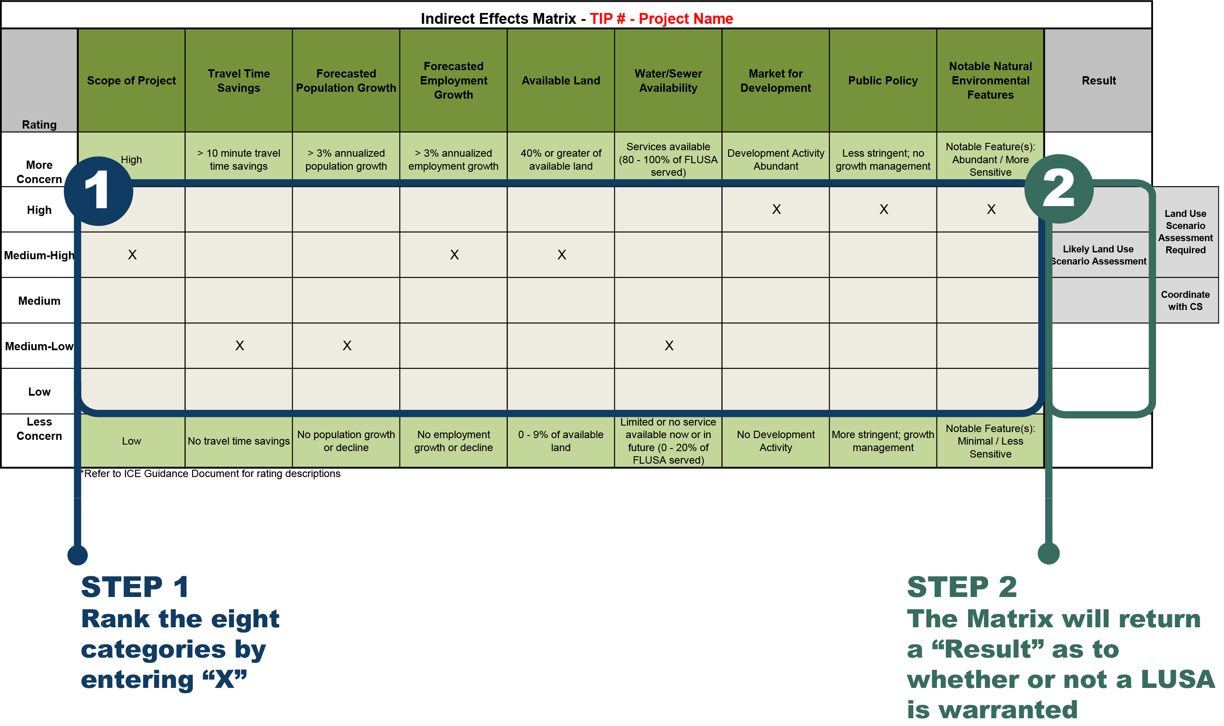

Appendix B: Mapping Guidance
Future Land Use Study Area Map
The map should contain the following layers and they should be displayed in this order:
- The STIP project being studied. Show individual alternatives/corridors if applicable.
- FLUSA Boundary in a solid, colored line (not black).
- All Roads. Use Highway Shield symbols with embedded route numbers as the label for Interstates, US and NC routes, and the local names (not SR numbers) of other state maintained secondary roads and local roads.
- Points indicating the location of major land use and traffic nodes (interchanges, dense commercial development centers).
- Hydrologic features, with labels.
- Any other property managed for conservation, preservation or recreational purposes (shaded or patterned polygon).
- State, county, municipal boundaries (outline states and counties, shade municipal polygons). Label municipalities on the map.
- Include a title, legend, scale bar, and north arrow.
- Provide the data sources of the GIS layers on the map.
Project Area Transportation Projects
The map should contain the following layers and they should be displayed in this order:
- STIP Points and Roads. Display and label with STIP number all of the projects that appear in the map context.
- FLUSA Boundary in a solid, colored line (not black).
- All Roads. Use Highway Shield symbols with embedded route numbers as the label for Interstates, US and NC routes, and the local names (not SR numbers) of other state maintained secondary roads and local roads.
- Hydrologic features.
- State, county, municipal boundaries (outline states and counties, shade municipal polygons).
- Include a title, legend, scale bar, and north arrow.
- Provide the data sources of the GIS layers on the map.
Notable Human Environmental Features Map
The map should contain the following layers and they should be displayed in this order:
- FLUSA Boundary in a solid, colored line (not black).
- Notable Human Environmental Features: bike routes, hurricane evacuation routes, strategic transportation corridors, cemeteries, community centers, active farmland, Voluntary Agricultural Districts (VADs), hospitals, fire stations, libraries, police and EMS stations, places of worship, and schools
- All Roads. Use Highway Shield symbols with embedded route numbers as the label for Interstates, US and NC routes, and the local names (not SR numbers) of other state maintained secondary roads and local roads.
- Hydrologic features.
- State, county, municipal boundaries (outline states and counties, shade municipal polygons).
- Include a title, legend, scale bar, and north arrow.
- Provide the data sources of the GIS layers on the map.
Notable Natural Environmental Features Map
The map should contain the following layers and they should be displayed in this order:
- FLUSA Boundary in a solid, colored line (not black).
- Notable Natural Environmental Features: habitat areas, Natural Heritage Program Natural Areas, major waterways, wetlands, water supply watershed areas, waters under jurisdiction of a NC Basinwide Management Plan, 303(d) listed streams, trout streams, Outstanding Resource Waters, NC Natural & Scenic Rivers, and US Wild & Scenic Rivers
- HUC boundaries, if they were used to define the FLUSA.
- All Roads. Use Highway Shield symbols with embedded route numbers as the label for Interstates, US and NC routes, and the local names (not SR numbers) of other state maintained secondary roads and local roads.
- State, county, municipal boundaries (outline states and counties, shade municipal polygons).
- Include a title, legend, scale bar, and north arrow.
- Provide the data sources of the GIS layers on the map.
Water and Sewer Availability Map
The map should contain the following layers and they should be displayed in this order:
- FLUSA Boundary in a solid, colored line (not black).
- Existing and Future Water Treatment and Wastewater Treatment Plants
- Existing and Future Water Distribution Service Areas and Sewer Service Areas
- All Roads. Use Highway Shield symbols with embedded route numbers as the label for Interstates, US and NC routes, and the local names (not SR numbers) of other state maintained secondary roads and local roads.
- Hydrologic features.
- State, county, municipal boundaries (outline states and counties, shade municipal polygons).
- Include a title, legend, scale bar, and north arrow.
- Provide the data sources of the GIS layers on the map.
Available Land Map
The map should contain the following layers and they should be displayed in this order:
- FLUSA Boundary in a solid, colored line (not black).
- Parcel outlines (if available)
- Land Available for Development (undeveloped (vacant) and underutilized)
- Developed Land
- All Roads. Use Highway Shield symbols with embedded route numbers as the label for Interstates, US and NC routes, and the local names (not SR numbers) of other state maintained secondary roads and local roads.
- Hydrologic features including wetlands
- State, county, municipal boundaries (outline states and counties, shade municipal polygons).
- Include a title, legend, scale bar, and north arrow.
- Provide the data sources of the GIS layers on the map.
GIS Data Sources
GIS data may be obtained from the municipal or county planning or GIS department where the project is located. Statewide data is available from NCDOT through its Enterprise GIS website and from NC One Map: https://connect.ncdot.gov/resources/gis/Pages/default.aspx | http://www.nconemap.net/

Appendix C: Standard Language

Standard Water Quality Language
The potential for the degradation of water quality also exists through erosion and stream sedimentation. Any direct natural environmental impacts by NCDOT projects would be addressed by avoidance, minimization, and mitigation consistent with programmatic agreements with the natural resource agencies during the Merger and Permitting processes.
Standard Natural Environmental Impact Language
Direct natural environmental impacts by NCDOT projects would be addressed by avoidance, minimization, or mitigation, consistent with programmatic agreements with the natural resource agencies during the Merger and Permitting processes.

Appendix D: Scope of Project Definitions
Low
Criteria:
- Limited or no increase in lane capacity
- Stays mostly within the existing right-of-way; limited or no new location required
- Limited or no travel time savings (<1 minute)
Examples of projects that meet these criteria:
- Interchange ramp modifications
- Cross-section changes, i.e. changing 4 lanes + center turn lane to 4 lane divided, creating a superstreet or adding turn lanes
- Short widening, such as adding an auxiliary lane between 2 interchanges
- Replacing an intersection with a new intersection design or interchange
- Pavement rehab, rockslide stabilization, new rest areas – probably no TICAs present
Medium-Low
Predominant project type:
- New location: Up to 2 miles
- Widening: Up to 5 miles
- New interchange
If the predominant project type is widening and there is a new location section, then the project would rank Medium.
Medium
Predominant project type:
- New location: 2 to 4 miles
- Widening: Over 5 miles
- New interchange
If the predominant project type is widening and there is a new location section, then the project would rank Medium-High.
Medium-High
New location: 4 to 6 miles
High
New location: Over 6 miles

